Data Guard Broker Setup, Switchover and Failover using Broker
DB01 Primary: Verify database role, archive destinations, and enable DB_BROKER_START
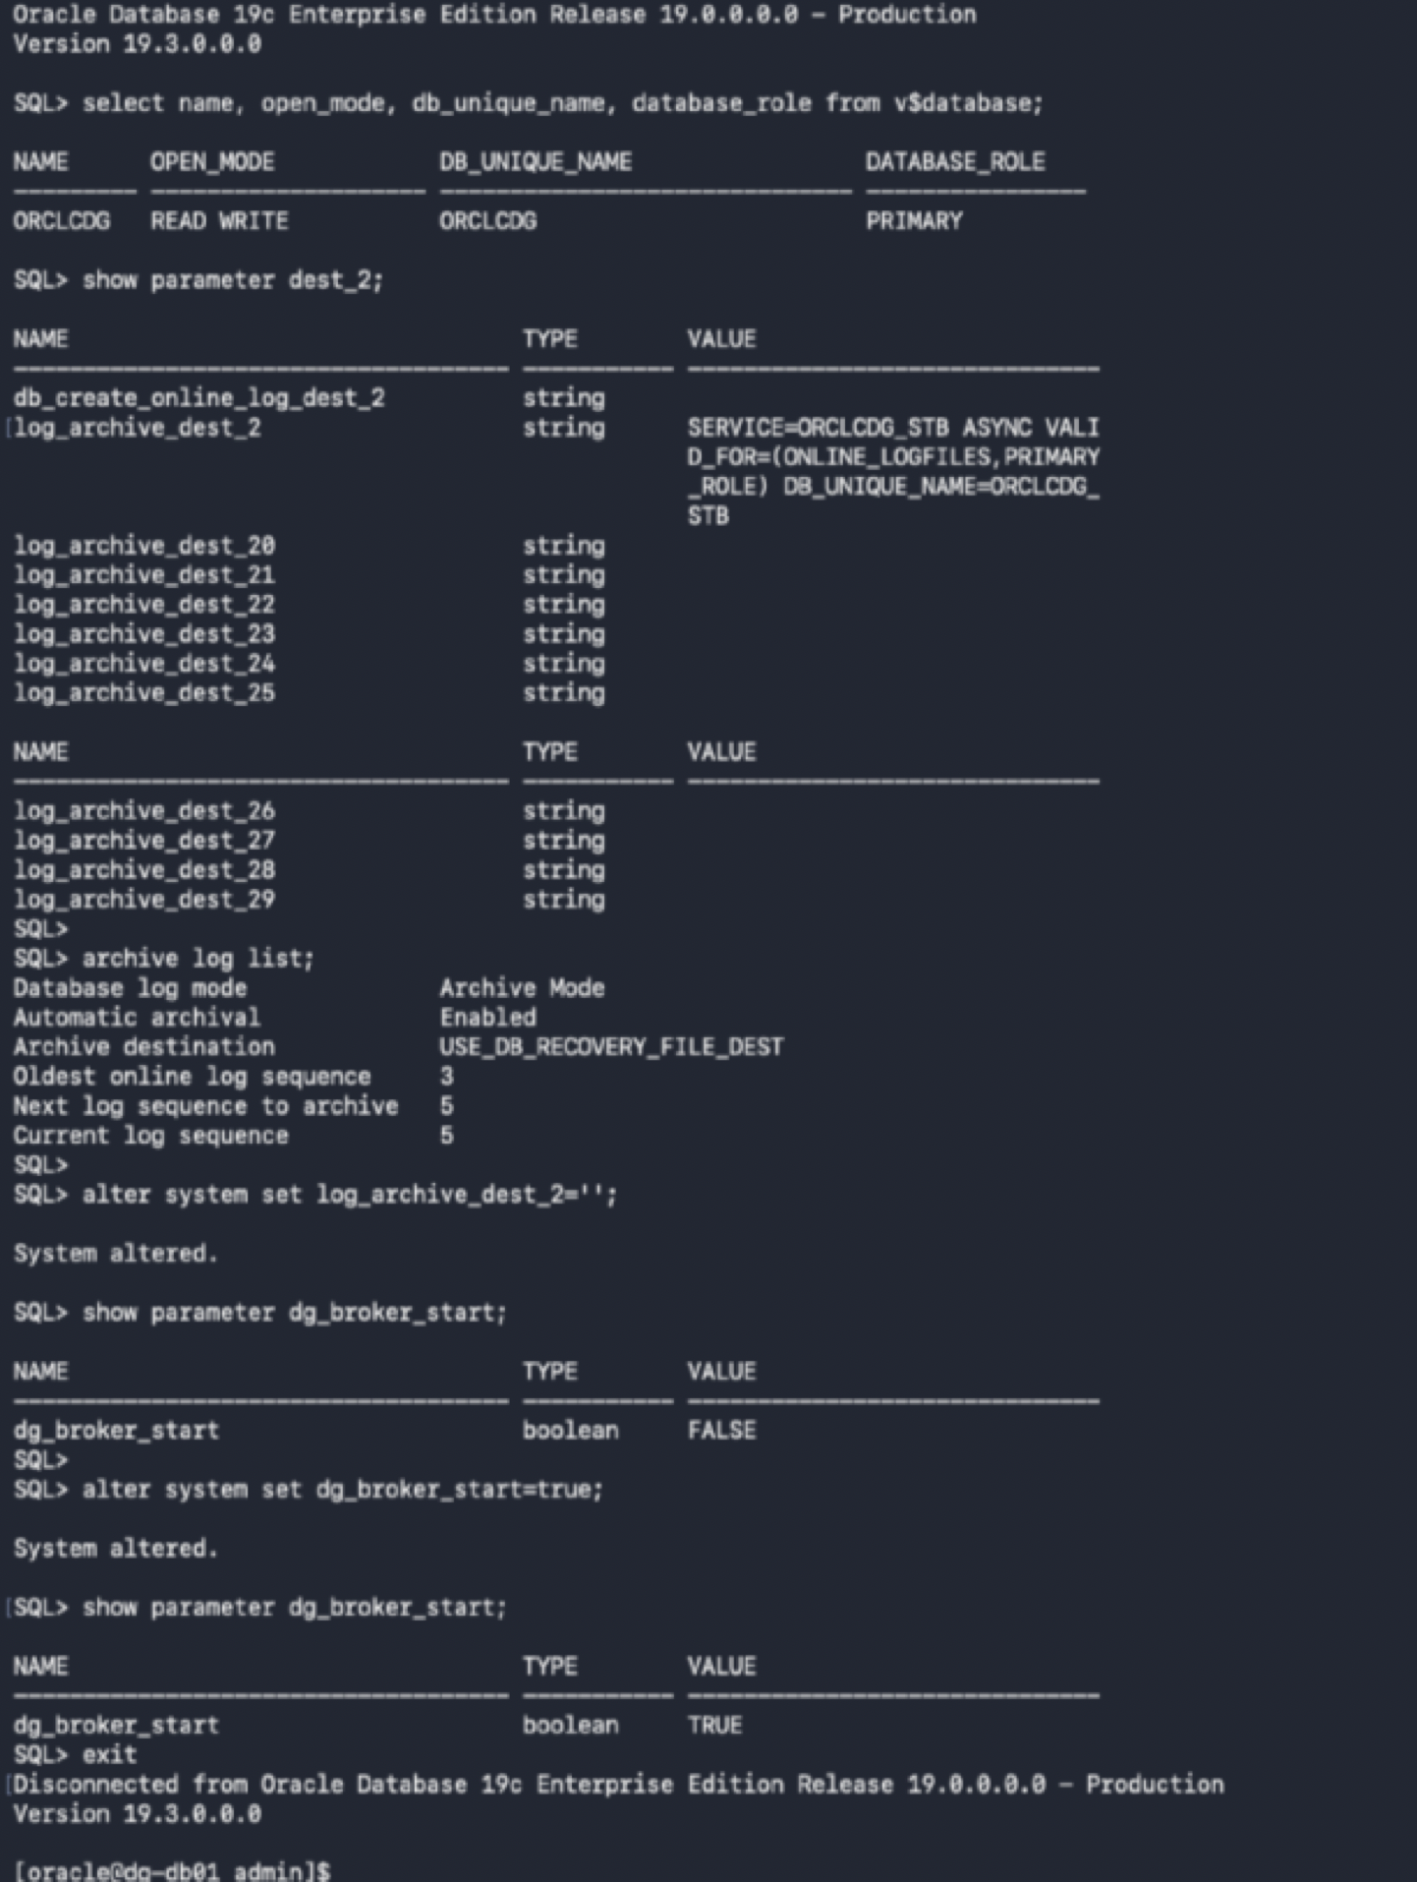

DB02 Standby: Verify physical standby role, archive destination, and enable DB_BROKER_START
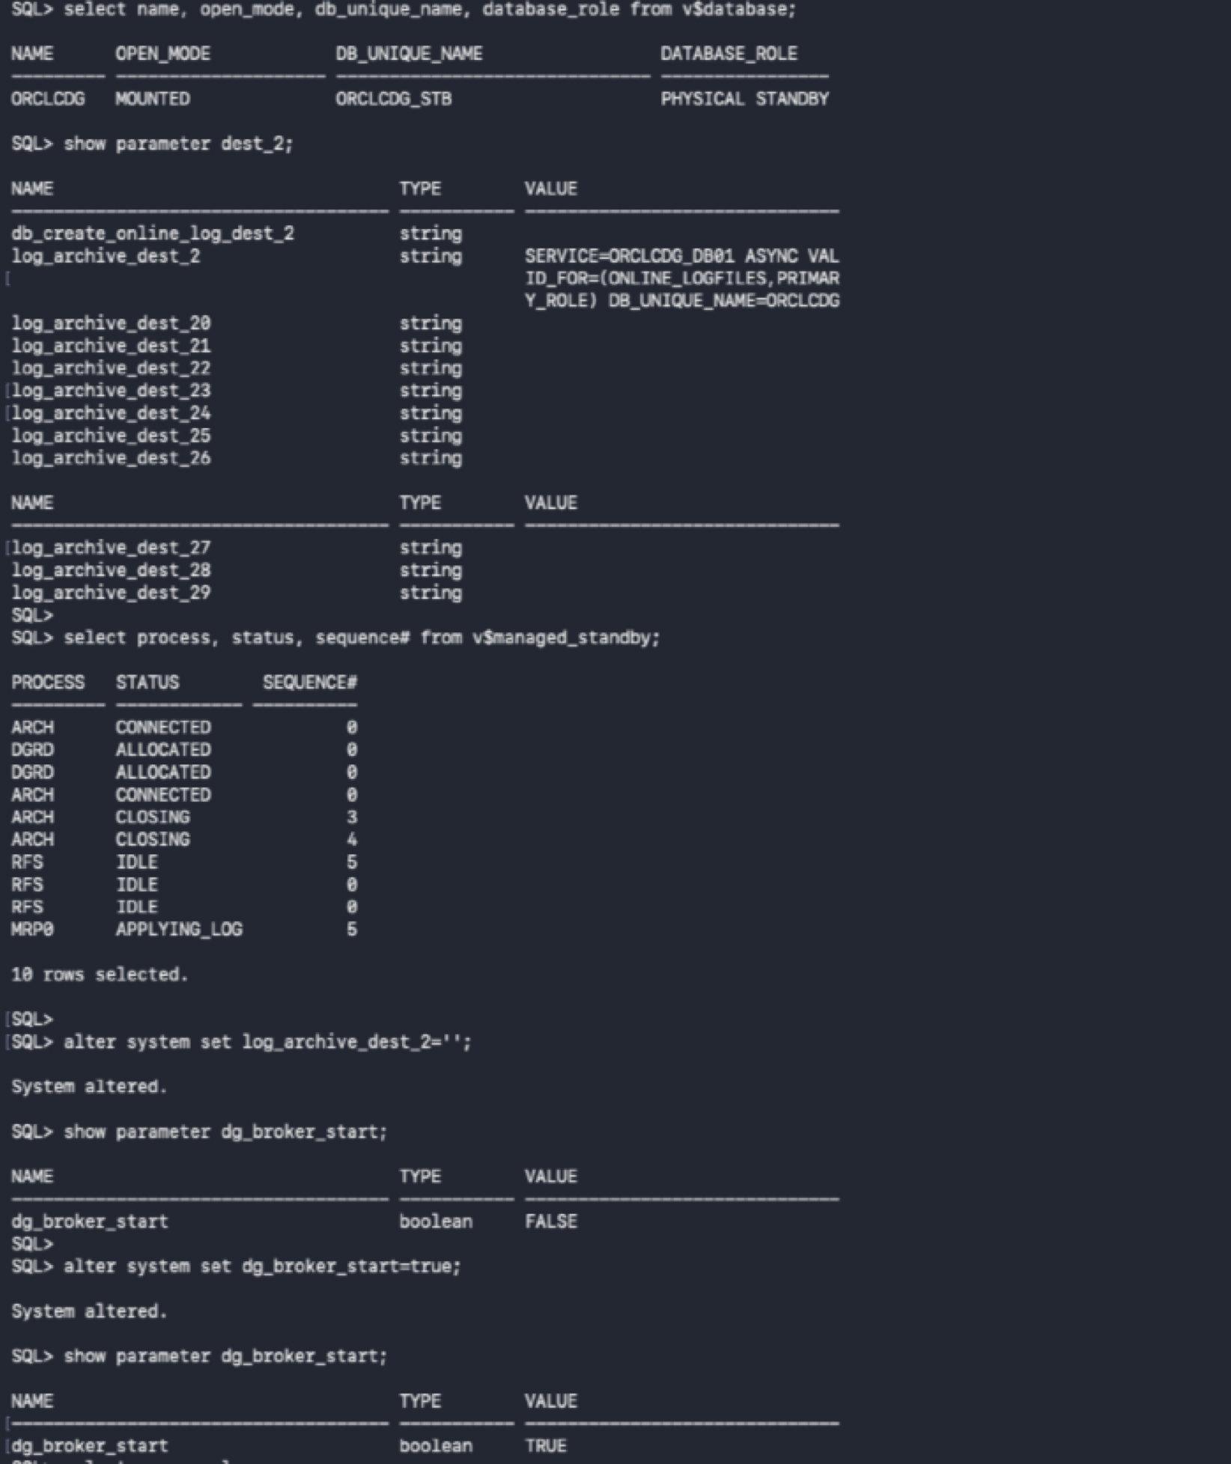
DB01: Create and enable the Data Guard Broker configuration
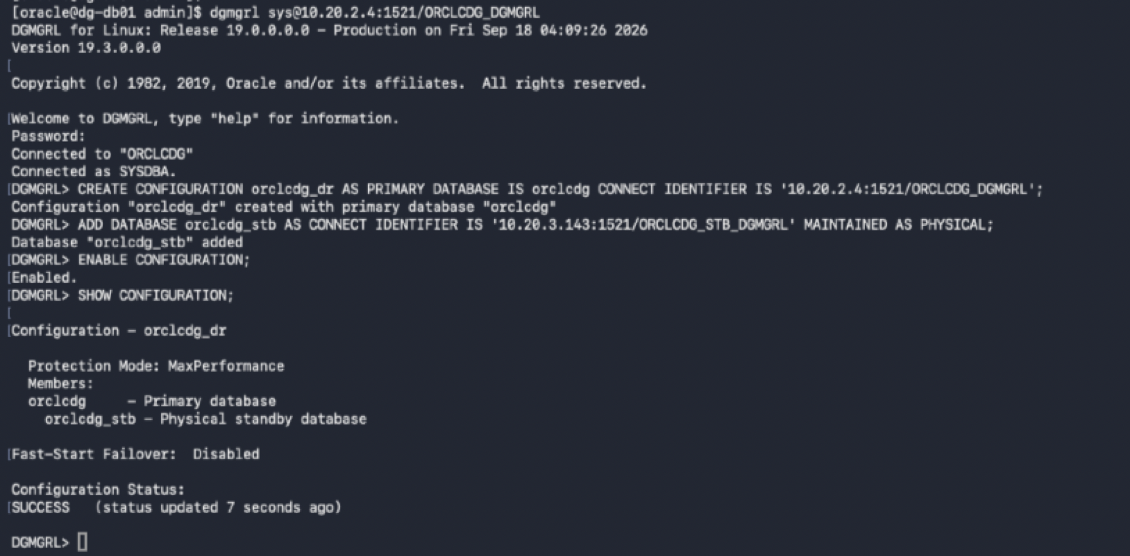

Broker: Verify configuration and database status
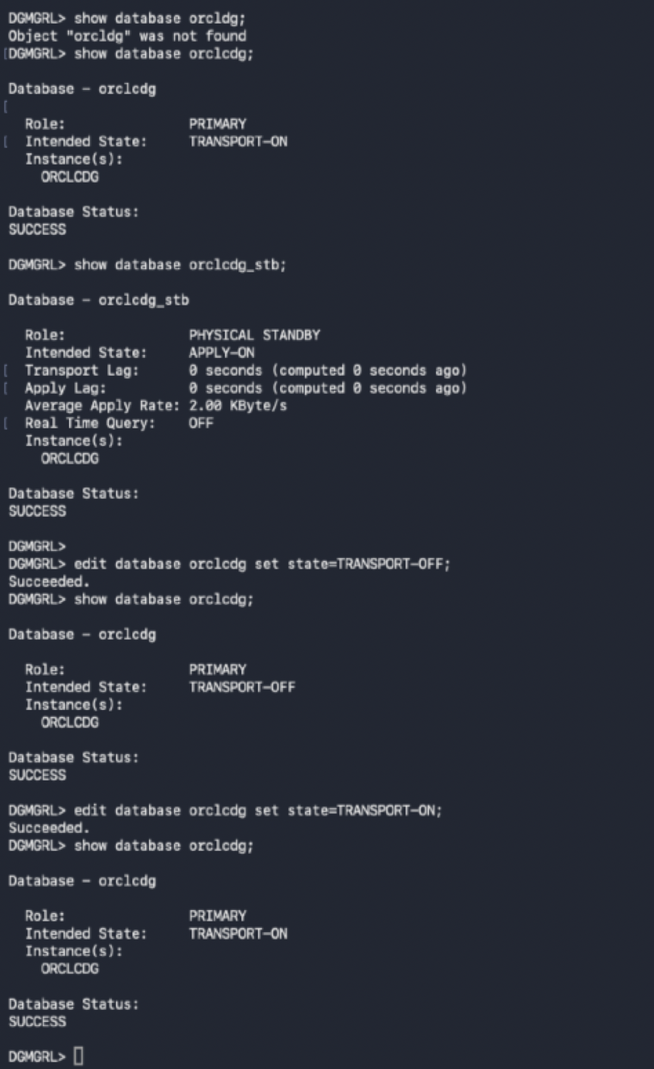
Broker: Perform Switchover to orclcdg_stb
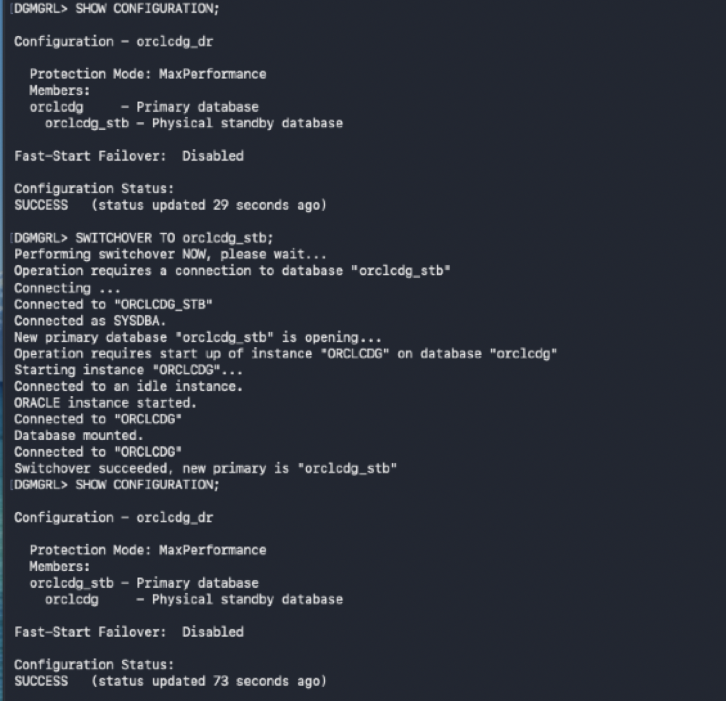

DB02 (Primary): Verify role after switchover
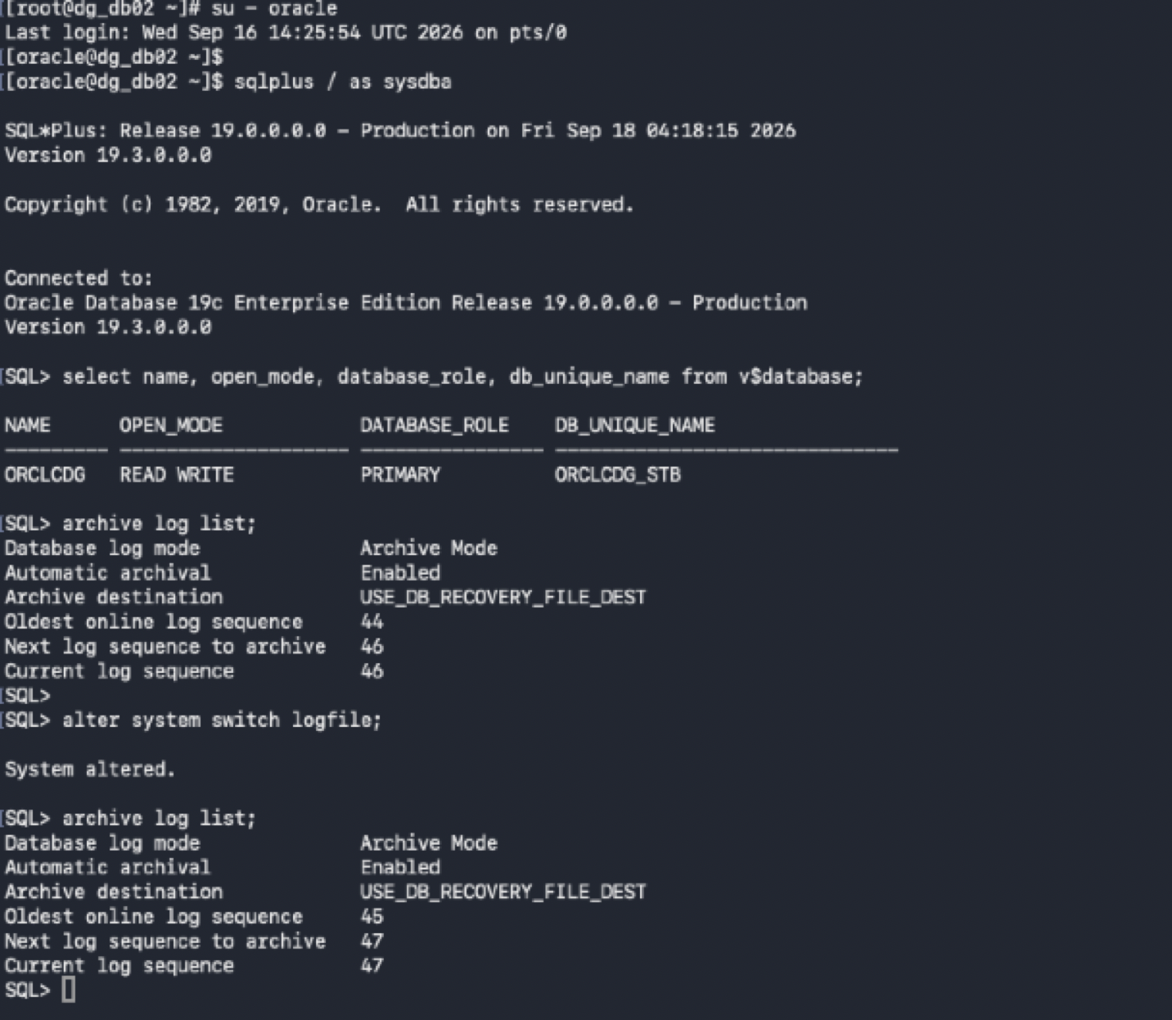

DB01 (Standby): Verify physical standby role and apply/transport lag
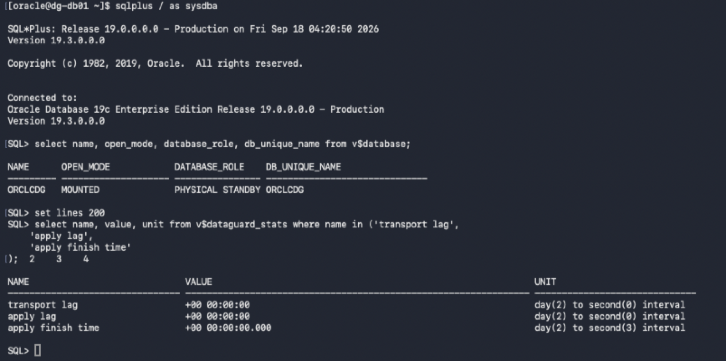

Broker: Switchover back to original primary DB01
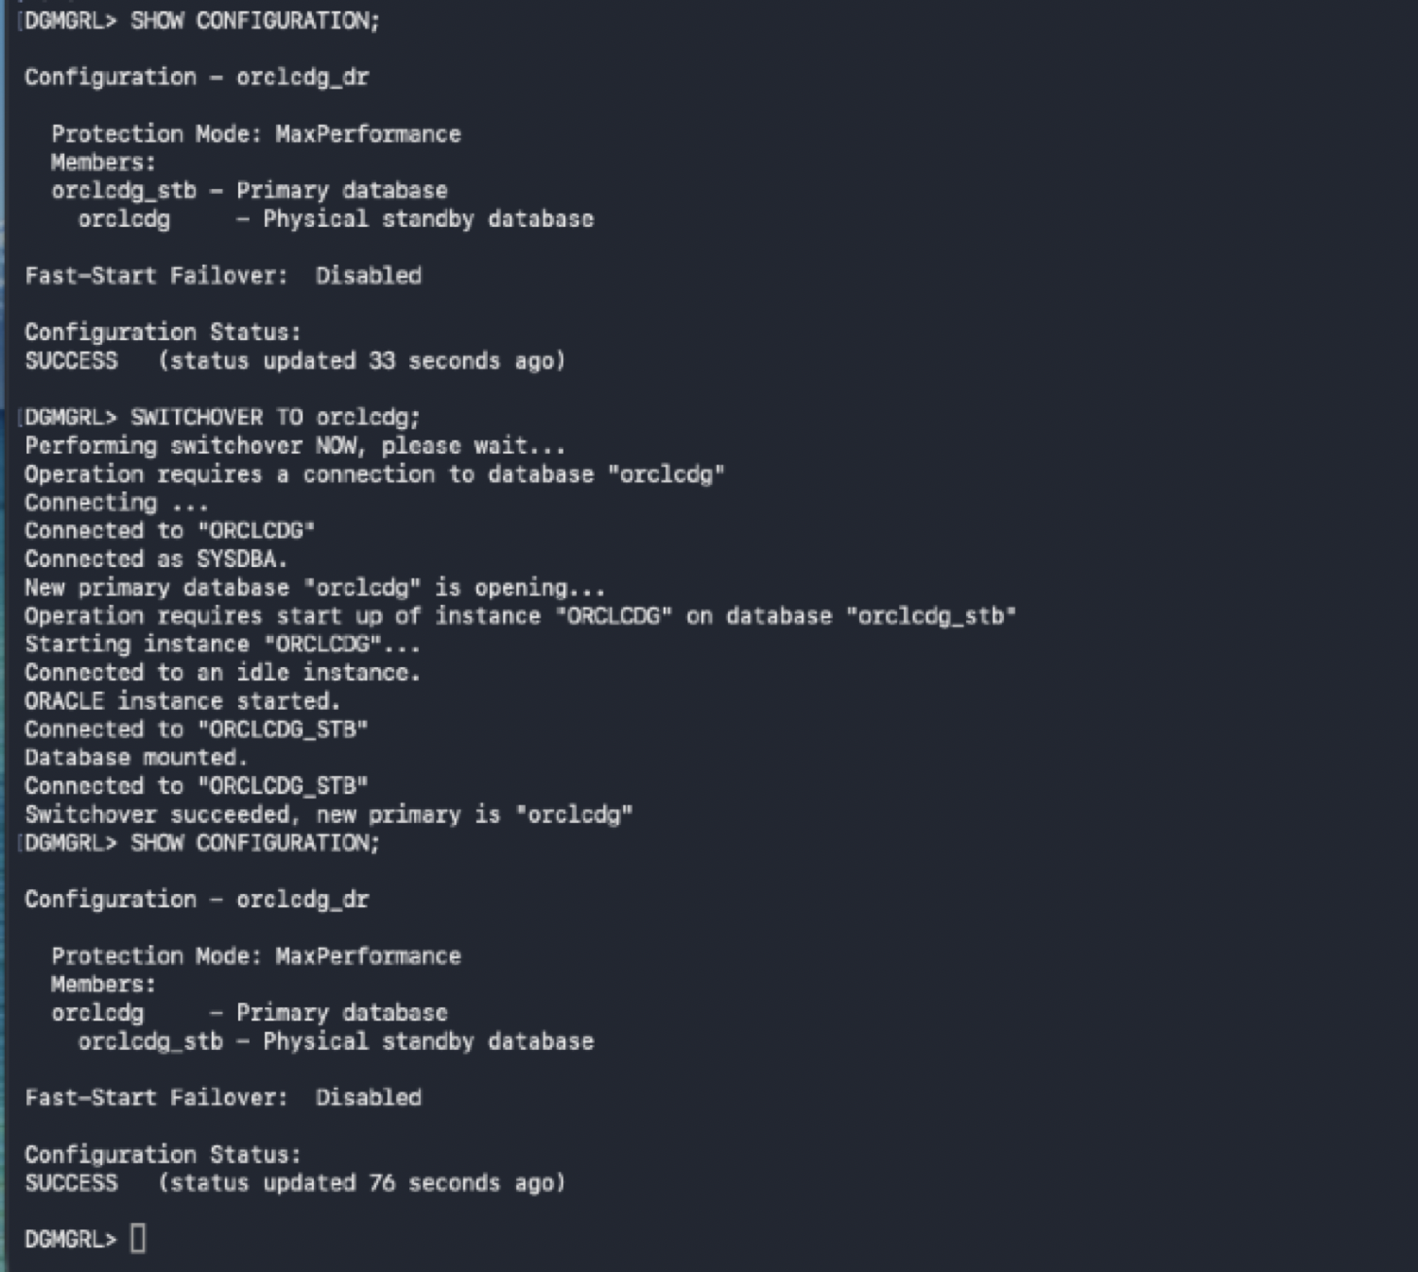

DB01: Confirm DB01 is primary after switchover
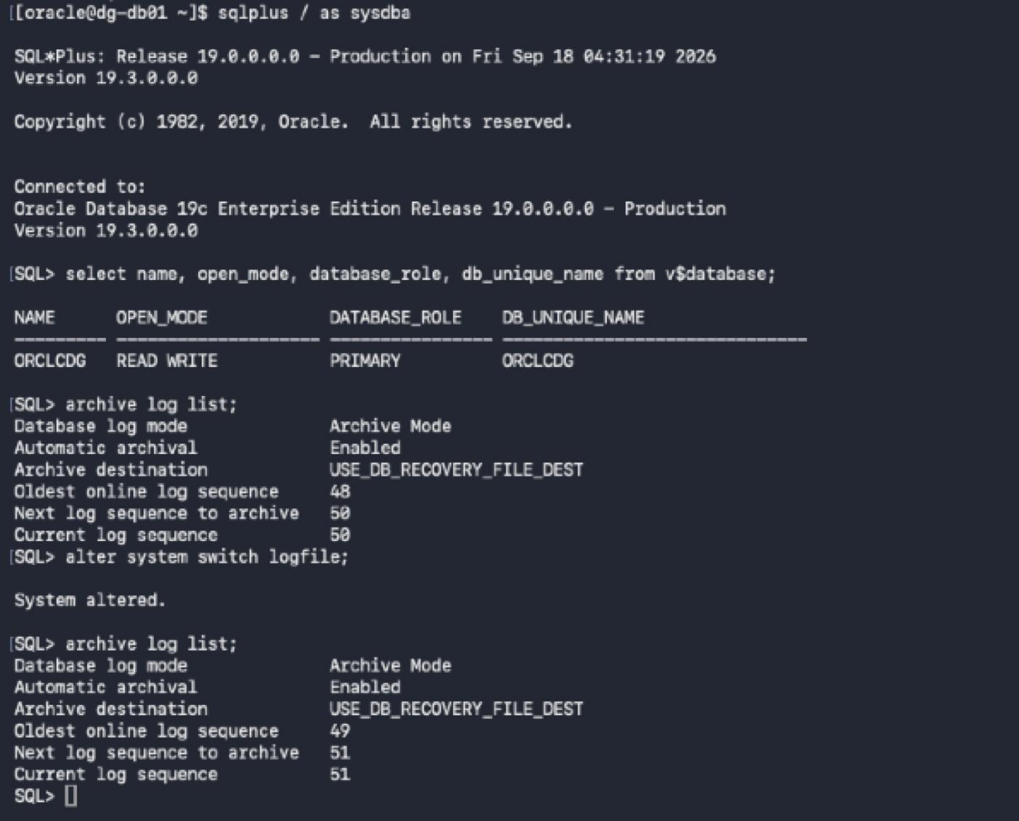

DB02: Confirm DB02 is standby and redo apply is active
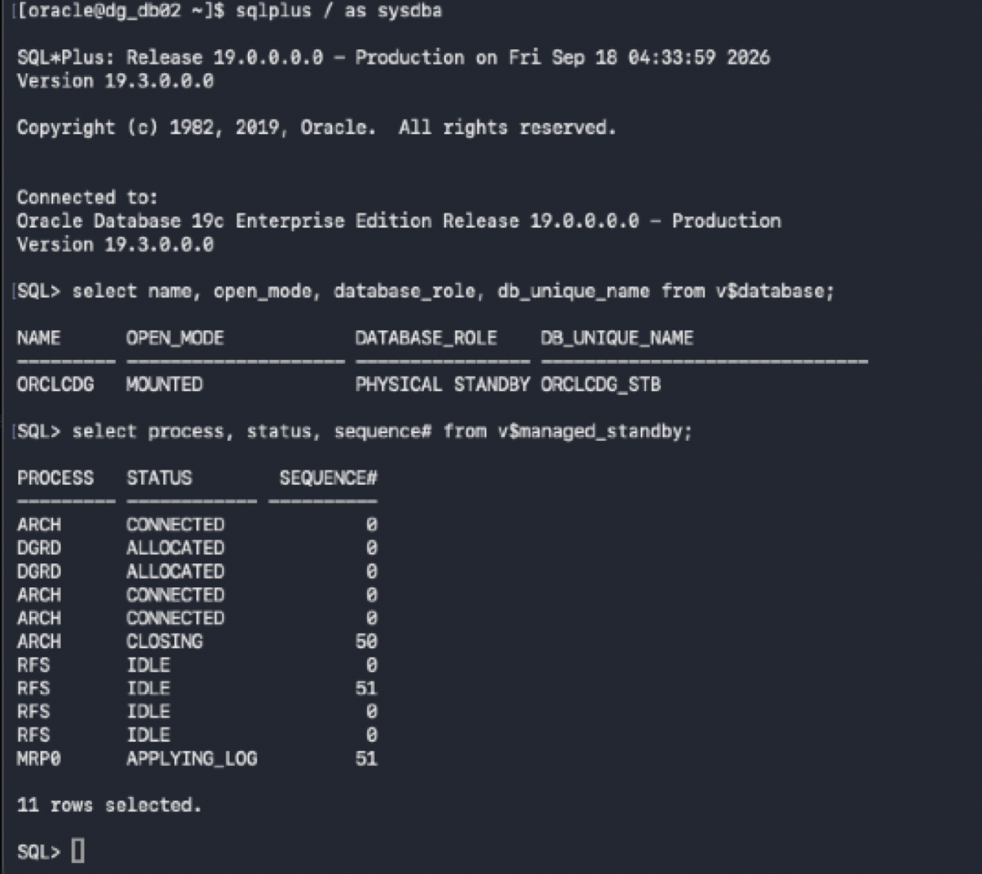

Broker: Perform failover to DB02 and reinstate DB01
Stimulate a crash on the primary database and perform a Failover:
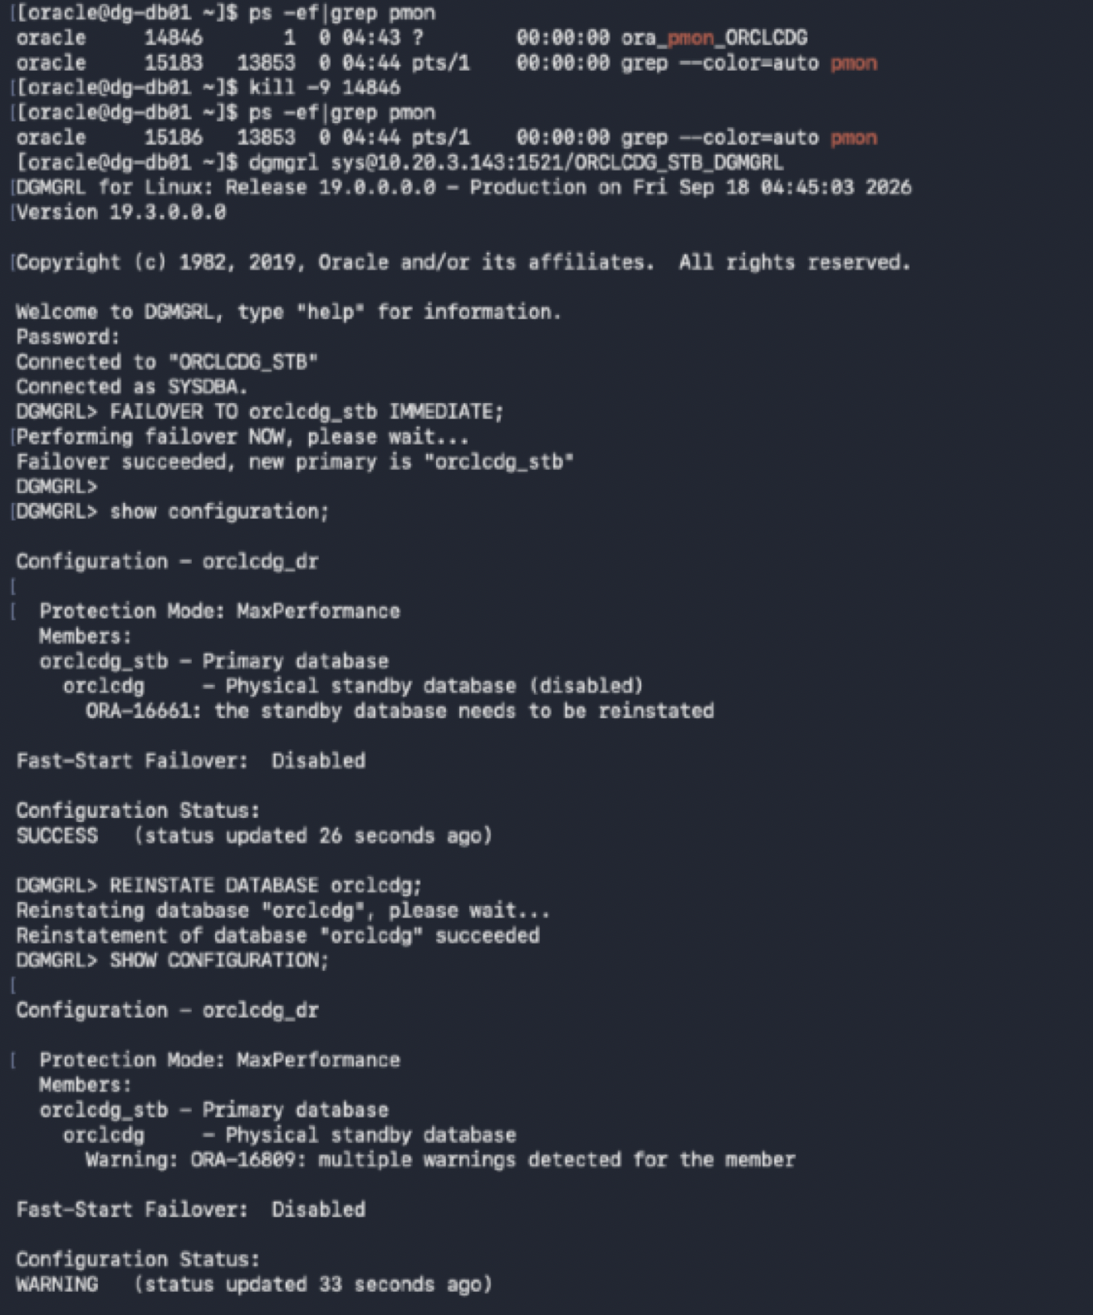
Broker: Verify DB01 standby status and review transport warnings
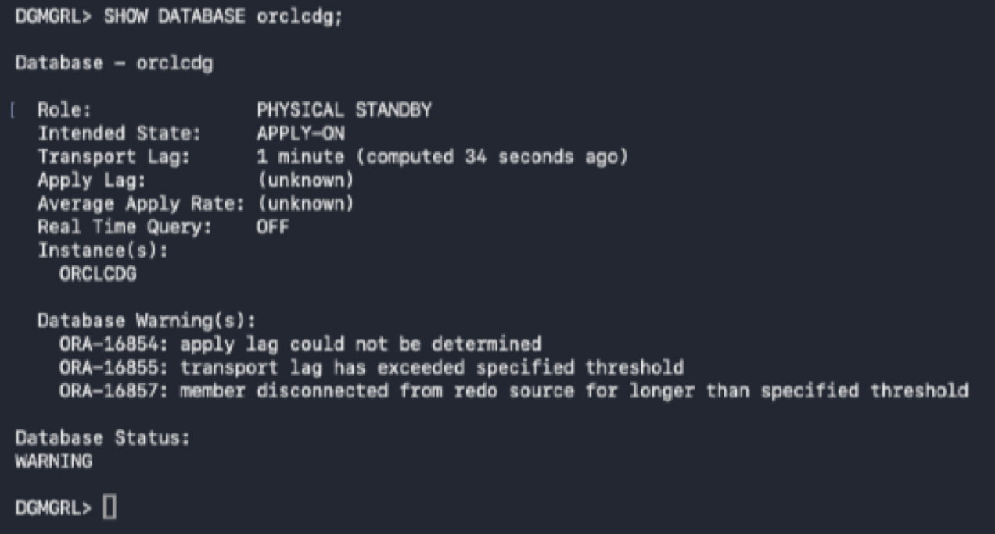
Broker: Verify DB01 is synchronized after reinstatement
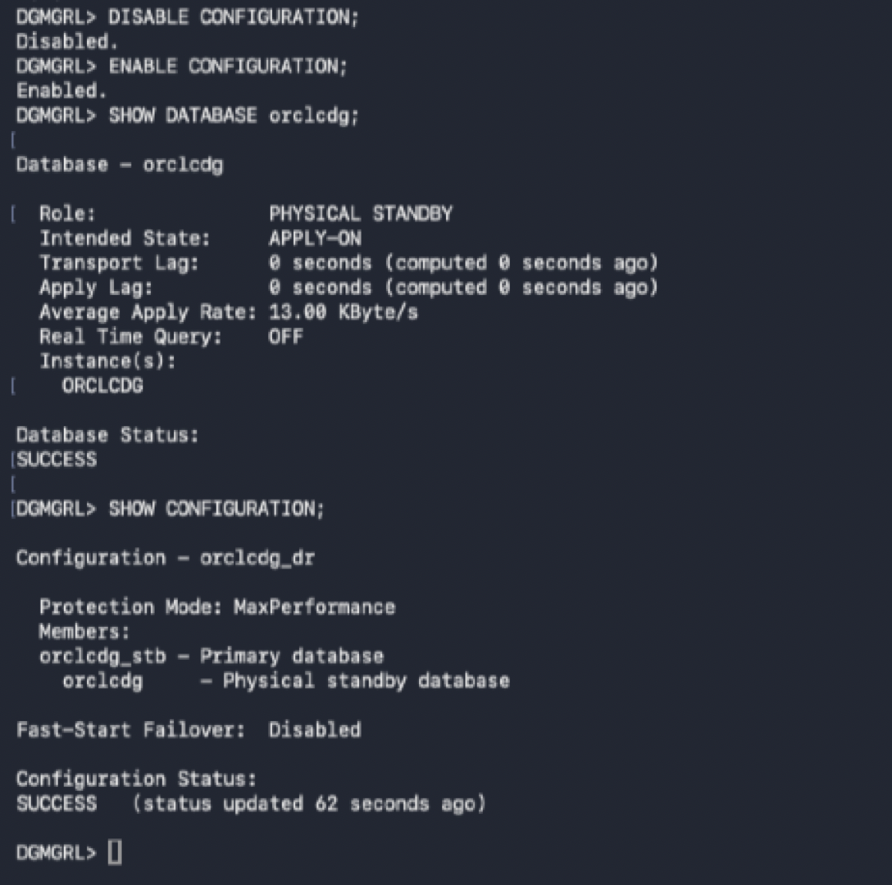
Broker: Switchover back to DB01 after failover and reinstatement
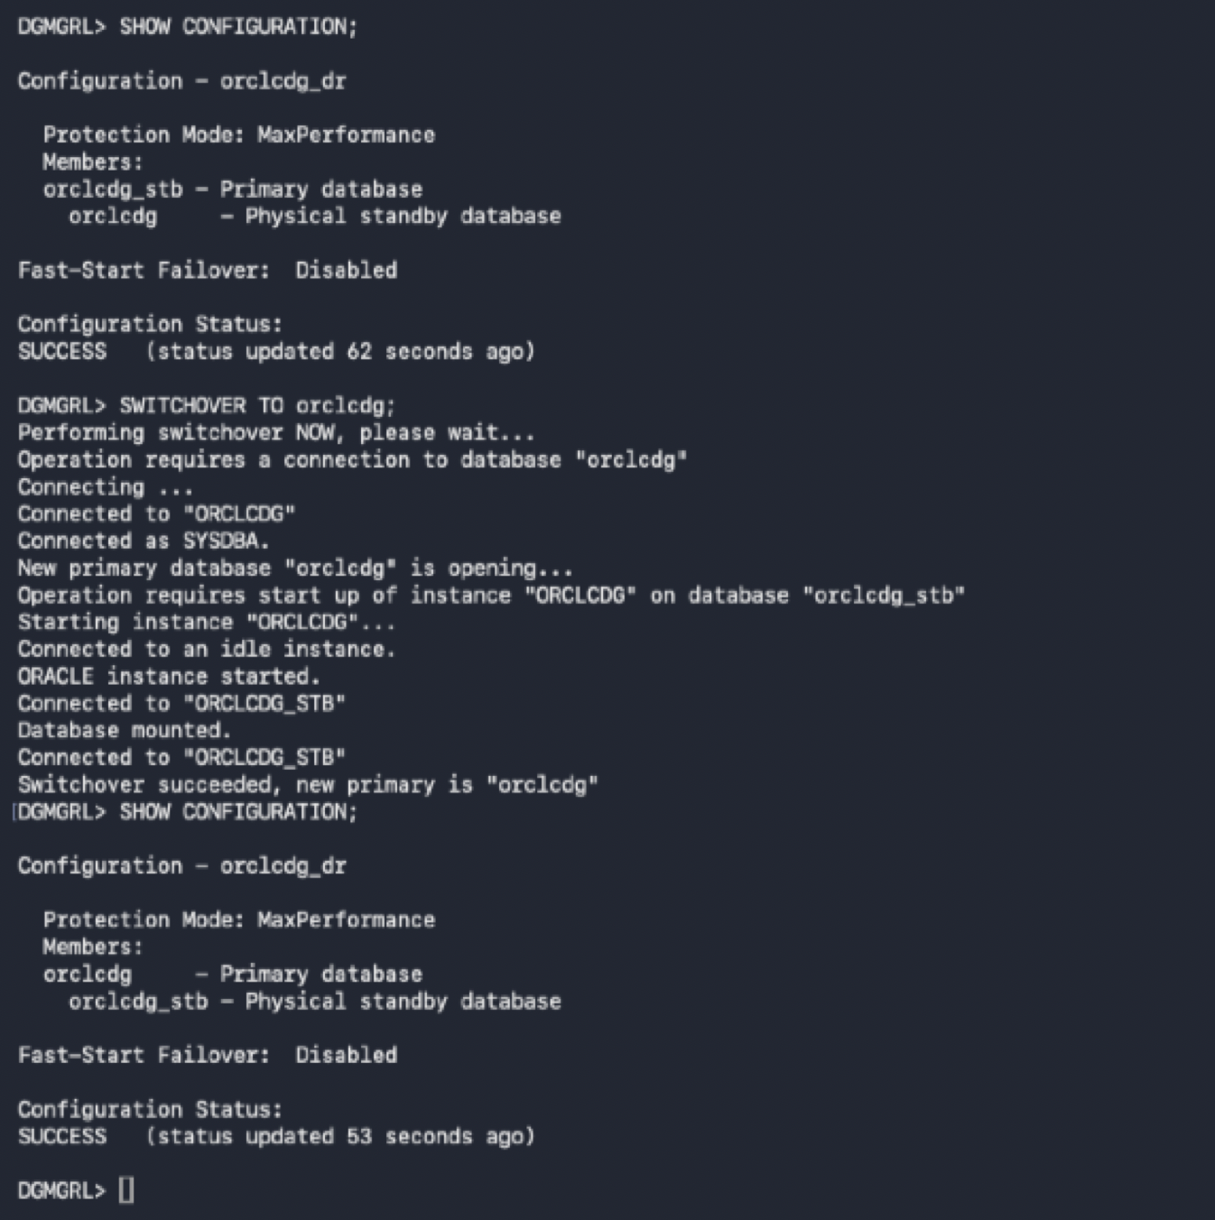

DB01 (Primary): Verify final primary state and GAP_STATUS = NO GAP
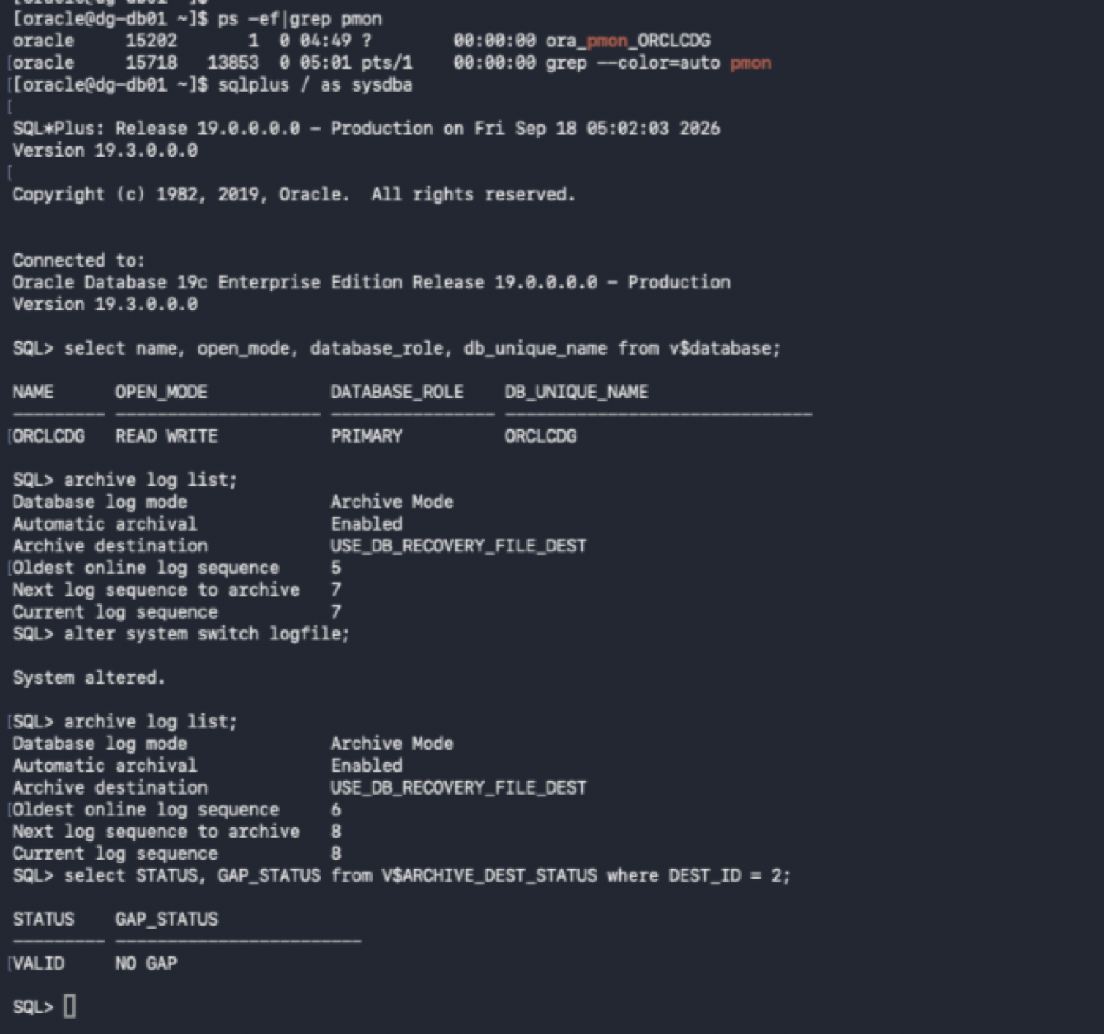

DB02 (Standby): Verify final physical standby state and zero transport/apply lag
